**COOK BOOK**

**Your Virtual Kitchen Assistant**

(React Application)

**TABLE OF CONTENTS**

1. INTRODUCTION
2. ABSTRACT
3. DESCRIPTION
4. REQUIREMENT SPECIFICATION
5. SYSTEM ARCHITECTURE
6. DATA FLOW DIAGRAM
7. TECHNOLOGY STACK
8. FEATURES OF COOKBOOK
9. PROJECT FLOW AND IMPLEMENTATION
10. CONCLUSION
11. **INTRODUCTION:**

Cooking has been an integral part of human culture for centuries, evolving from traditional handwritten recipes to digital platforms that offer a seamless experience for discovering and organizing recipes. With the advancement of technology, food lovers now seek convenient, accessible, and interactive ways to explore new dishes. *CookBook: Your Virtual Kitchen Assistant* is a web-based application designed to cater to food enthusiasts, home cooks, and professional chefs. It provides a user-friendly interface for browsing, searching, and managing a vast collection of recipes from around the world. This project aims to simplify the cooking experience by integrating an interactive search functionality powered by the *MealsDB API*, allowing users to access thousands of recipes categorized by cuisine, ingredients, and meal types. The application ensures smooth navigation, visually appealing content, and easy-to-follow cooking instructions, making it an ideal platform for individuals looking to experiment with new flavors. CookBook is built using *React.js* for the frontend, ensuring a dynamic and responsive interface, and leverages API integration to fetch real-time data. The project is designed with a well-structured architecture that includes various components such as *recipe categories, trending dishes, detailed recipe pages, and user-friendly navigation*. By offering an efficient way to explore and manage recipes, CookBook enhances the culinary journey for users, making cooking an enjoyable and hassle-free experience. Whether someone is a beginner learning to cook or an experienced chef seeking inspiration, CookBook serves as a comprehensive digital kitchen companion.

1. **ABSTRACT:**

CookBook: Your Virtual Kitchen Assistant is a web-based recipe application designed to enhance the cooking experience by providing a vast collection of recipes through an interactive and user-friendly platform. Built using *React.js, the application seamlessly integrates the **MealsDB API* to fetch real-time recipe data, allowing users to search for dishes, explore various cuisines, and access detailed cooking instructions.

The primary objective of CookBook is to simplify recipe discovery and organization by offering features such as *category-based browsing, trending dishes, and an intuitive search function*. The platform ensures a visually appealing and interactive interface, catering to both novice cooks and professional chefs. By leveraging modern web technologies, CookBook provides an efficient and enjoyable way to discover, save, and manage recipes, making it a valuable digital companion for culinary enthusiasts.

1. **DESCRIPTION:**

CookBook: Your Virtual Kitchen Assistant is an innovative web application designed to revolutionize how users discover, organize, and explore recipes. Whether you're a beginner looking for easy meal ideas or a professional chef seeking inspiration, CookBook provides a seamless and engaging platform to enhance your culinary experience.

Developed using *React.js, the application utilizes the **MealsDB API* to fetch real-time recipe data, offering users access to a vast collection of international dishes. The intuitive interface allows users to browse recipes by category, search for specific dishes, and view trending meals. Each recipe includes *detailed instructions, ingredient lists, and step-by-step cooking guidance*, ensuring an easy and efficient cooking process.

CookBook focuses on user convenience with a *modern design, interactive elements, and fast-loading pages*. With its advanced recipe management system and smooth navigation, CookBook transforms cooking into an enjoyable and hassle-free experience, making it the ultimate digital cookbook for every food enthusiast.

1. **REQUIREMENT SPECIFICATION:**

The CookBook: Your Virtual Kitchen Assistant is a web-based application designed to provide users with an interactive and seamless recipe discovery experience. The system requirements are categorized into functional, non-functional, hardware, and software specifications.

1. Functional Requirements

- Users can *search for recipes* using keywords.

- Recipes are *fetched from the MealsDB API* dynamically.

- Users can *browse recipes by categories* (e.g., breakfast, lunch, dinner).

- Detailed *recipe pages* display ingredients, cooking steps, and images.

- A *trending dishes section* showcases popular recipes

.

2. Non-Functional Requirements

- The application must have a *responsive design* for desktop and mobile devices.

- Pages should load within *3 seconds* for an optimal user experience.

- The system must ensure *secure API calls* to prevent unauthorized access.

- The application should be *scalable* to handle multiple users.

3. Software Requirements

- Frontend: React.js

- Backend (optional for user preferences): Node.js with Express (if needed)

- Database (optional for user preferences): MongoDB / Firebase

- API: MealsDB API for fetching recipe data

- Code Editor: Visual Studio Code (VS Code)

4. Hardware Requirements

- Processor: Intel i3 or higher

- RAM: Minimum 4GB (8GB recommended)

- Storage: Minimum 10GB of free space

- Operating System: Windows, macOS, or Linux

This structured requirement specification ensures that CookBook is efficient, scalable, and user-friendly, providing a seamless cooking experience for users worldwide.

1. **SYSTEM ARCHITECTURE:**

The CookBook: Your Virtual Kitchen Assistant follows a *three-tier architecture*, ensuring modularity, scalability, and efficient data management. The system architecture consists of the following layers:

1. Presentation Layer (Frontend)

- Built using *React.js* for a dynamic and responsive user experience.

- Users interact with a *search bar*, category-based browsing, and recipe details pages.

- Fetches data from the backend or *directly from the MealsDB API*.

2. Application Layer (Backend)

- (Optional) If user preferences need to be stored, a *Node.js with Express.js backend* can be used.

- Handles API requests, processes user interactions, and communicates with external APIs.

- Ensures security with authentication and API call management.

3. Data Layer (API & Data base)

- The *MealsDB API* provides real-time recipe data, including ingredients, images, and instructions.

- (Optional) A *database like MongoDB or Firebase* can be integrated to store user preferences or favorite recipes.

*Workflow of the System*

1. The *user searches for a recipe* or browses categories.

2. The *frontend (React.js) sends an API request* to fetch relevant data.

3. The *MealsDB API* responds with *recipe details* (ingredients, instructions, images).

4. The *frontend processes the response* and displays the recipes dynamically.

5. If a backend is used, *user preferences* (e.g., saved recipes) are stored in a *database*.

This architecture ensures *efficient performance, **real-time recipe updates, and **a smooth user experience* while keeping the system flexible for future enhancements.

1. **DATAFLOWDIAGRAM:**

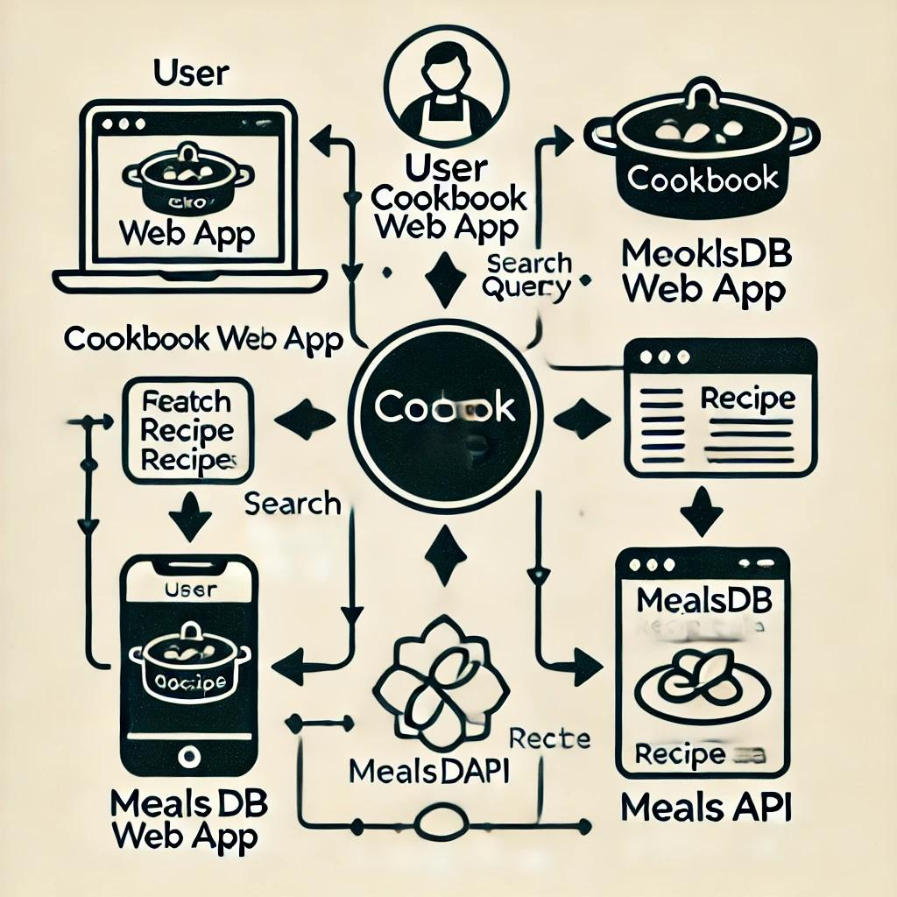

1. **TECHNOLOGY STACK:**

The *CookBook* project is built using modern web technologies to ensure efficiency, scalability, and a smooth user experience. Below is the technology stack used:

Frontend (Client-Side)

- React.js – For building the interactive user interface.

- React Router Dom – For handling navigation and routing.

- Axios – For making API requests to fetch recipe data from the MealsDB API.

- HTML5 & CSS3 – For structuring and styling the web pages.

- Bootstrap/Tailwind CSS – For a responsive and modern UI design.

Backend (Server-Side) - Optional

- Node.js with Express.js(if backend is used) – For handling server-side logic.

- MongoDB / Firebase (if user preferences are stored) – For storing user data.

API Integration

MealsDB API – For retrieving recipe details, categories, and trending dishes.

Development Tools & Environment

- Visual Studio Code (VS Code) – Code editor for development.

- Git & GitHub – For version control and project collaboration.

- Postman – For testing API requests.

This technology stack ensures that CookBook is efficient, user-friendly, and easy to maintain.

1. **FEATURES OF COOKBOOK:**

The *CookBook* project is a recipe web application that provides users with an interactive and seamless cooking experience. Below are the key features:

1. Recipe Search

- Users can search for recipes based on ingredients, dish names, or categories.

- Real-time filtering for quick results.

2. Trending Dishes

- Displays the most popular and trending recipes.

- Helps users explore new and exciting dishes.

3. Recipe Categories

- Organized recipe collection based on meal types (Breakfast, Lunch, Dinner).

- Easy navigation for users to find specific recipes.

4. Detailed Recipe View

- Each recipe includes ingredients, cooking steps, and preparation time.

- Images and videos (if available) to guide users.

5. API Integration (MealsDB API)

- Fetches real-time recipe data dynamically.

- Ensures a constantly updated recipe database.

6. Responsive Design

- Works on desktops, tablets, and mobile devices.

- Smooth user experience across different screen sizes.

7. Favorites & User Preferences (Optional)

- Users can save favorite recipes for future reference.

- Personalized recommendations based on user history.

These features make *CookBook* a useful and user-friendly platform for discovering and cooking delicious recipes effortlessly.

1. **PROJECTFLOWAND**

**IMPLEMENTATION:**

1. Project Flow

The *CookBook* project follows a structured flow to ensure smooth functionality:

1. User Interaction:

- The user accesses the web application.

- Searches for recipes using keywords or categories.

2. Request Processing:

- The frontend (React.js) captures the user’s input.

- Sends an API request to fetch relevant recipes.

3. Data Fetching:

- The MealsDB API processes the request.

- Retrieves recipe details, including ingredients, instructions, and images.

4. Displaying Results:

- The frontend receives API response data.

- Displays the recipes dynamically on the user interface.

5. User Actions:

- Users can view detailed recipes, save favorites, or explore trending dishes.

- Navigation through different categories is enabled.

6. Responsive Interaction:

- The application ensures smooth navigation on different devices.

- User experience is optimized for performance and accessibility.

2. Implementation Steps

The implementation of *CookBook* involves the following steps:

Step 1: Project Setup

- Initialize a React.js project.

- Set up the folder structure (components, pages, assets).

Step 2: API Integration

- Fetch recipe data from the MealsDB API using fetch or Axios.

- Process API responses and display results dynamically.

Step 3: UI Development

- Create *Home, Search, Recipe Details, and Category* pages.

- Use CSS and responsive design for a visually appealing interface.

Step 4: Data Handling & State Management

- Implement state management using React hooks (use State, use Effect).

- Ensure smooth navigation between pages with *React Router*.

Step 5: Testing & Debugging

- Test API calls and UI responsiveness.

- Fix issues related to API loading and broken UI elements.

Step 6: Deployment

- Host the application using Netlify or Vercel.

- Ensure it is accessible online for users.

This structured approach ensures that *CookBook* is well-implemented, user-friendly, and performs efficiently across devices.

* **HOME PAGE: SCREENSHOT**

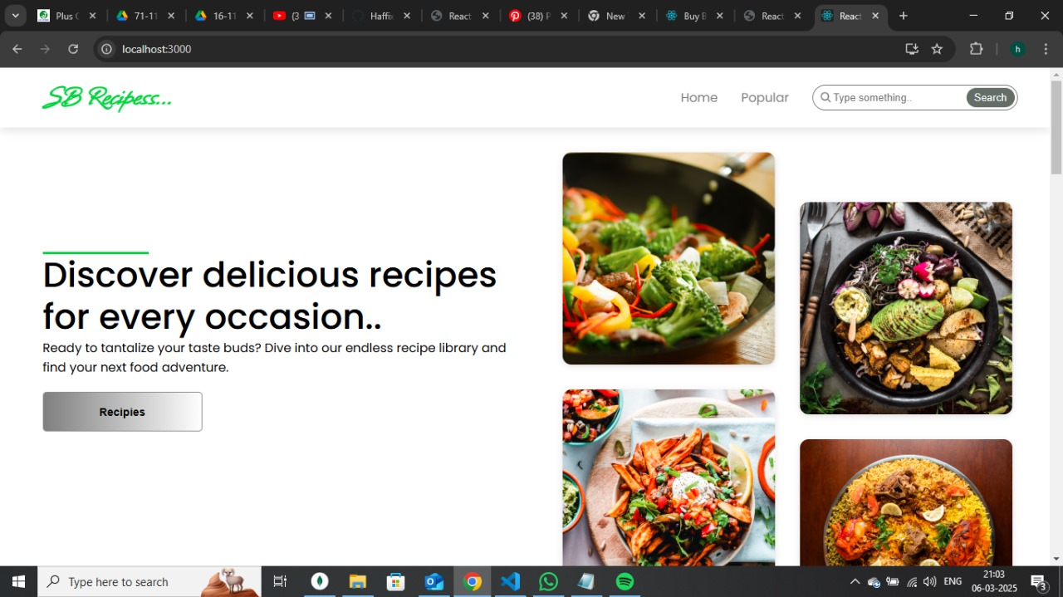

* **CATEGORIES PAGE:**

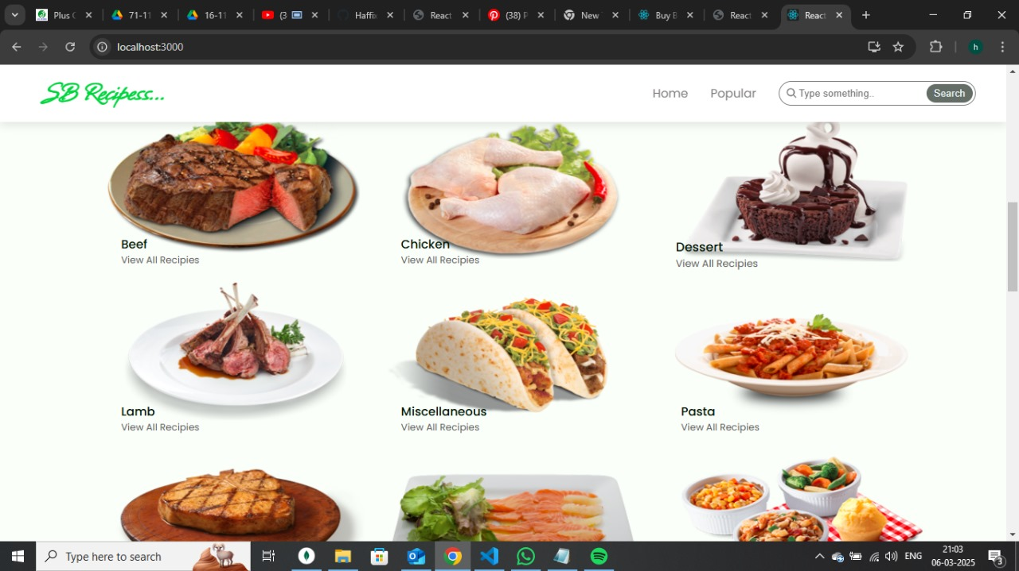

* **RECIPE LIST PAGE:**

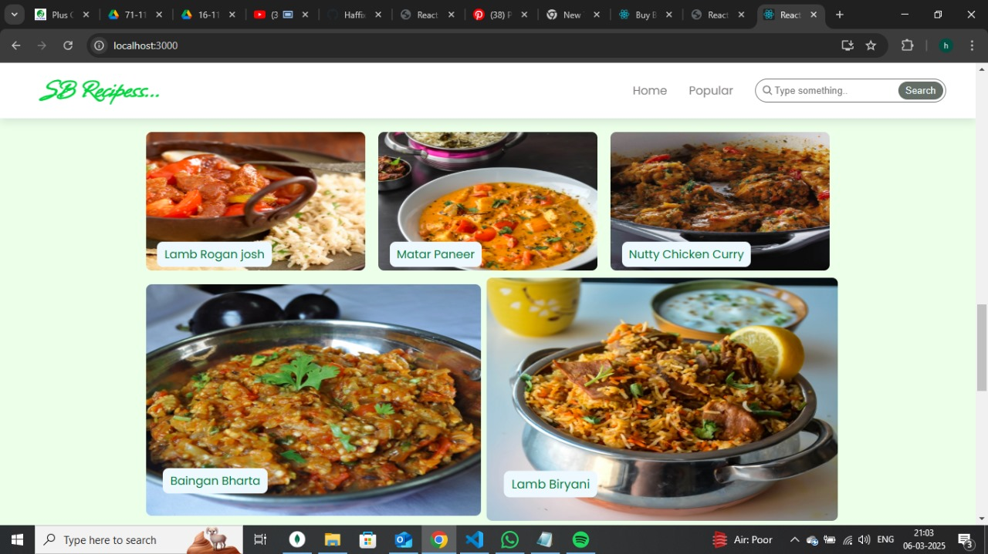

* **CATEGORY PAGE FOR CHICKEN RECIPES:**

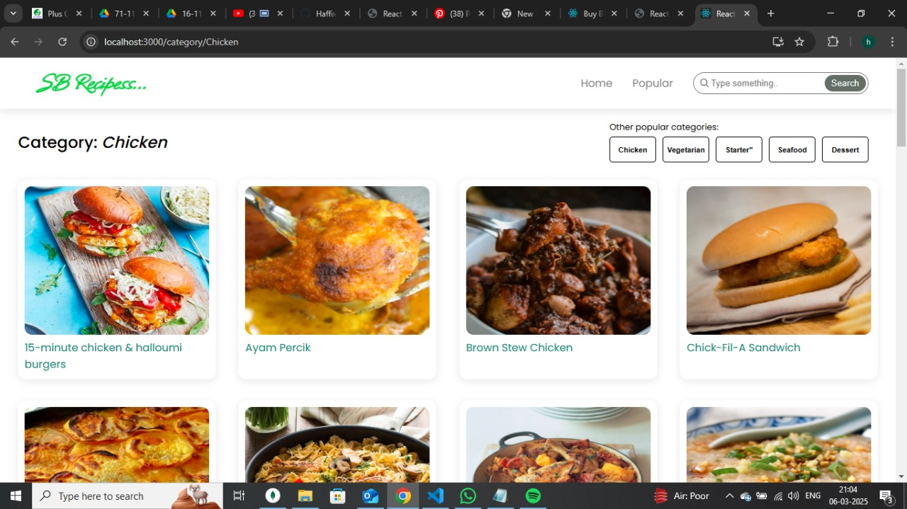

* **RECIPE DETAILS PAGE:**

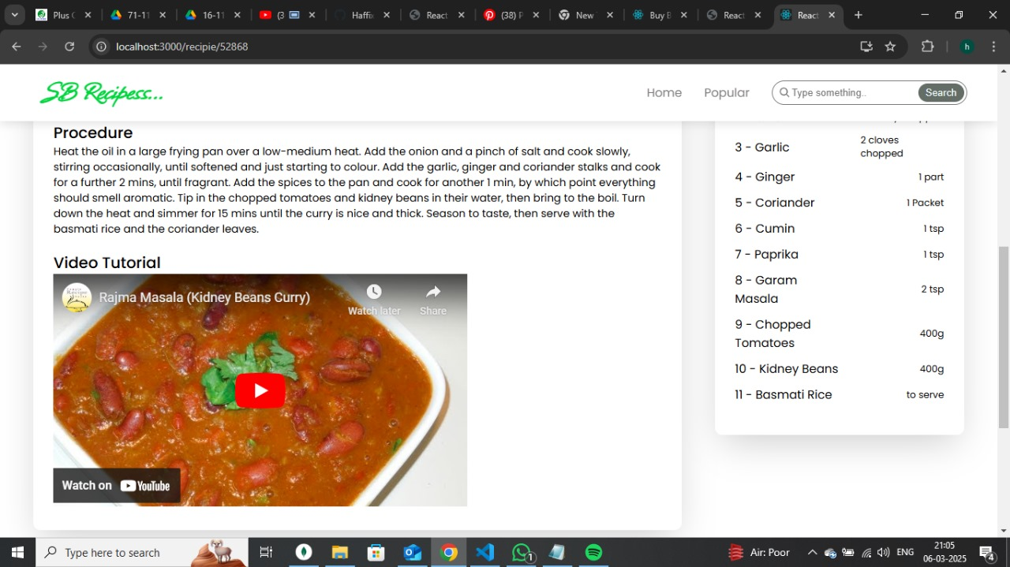

* **CATEGORY FOR LAMB RECIPES:**

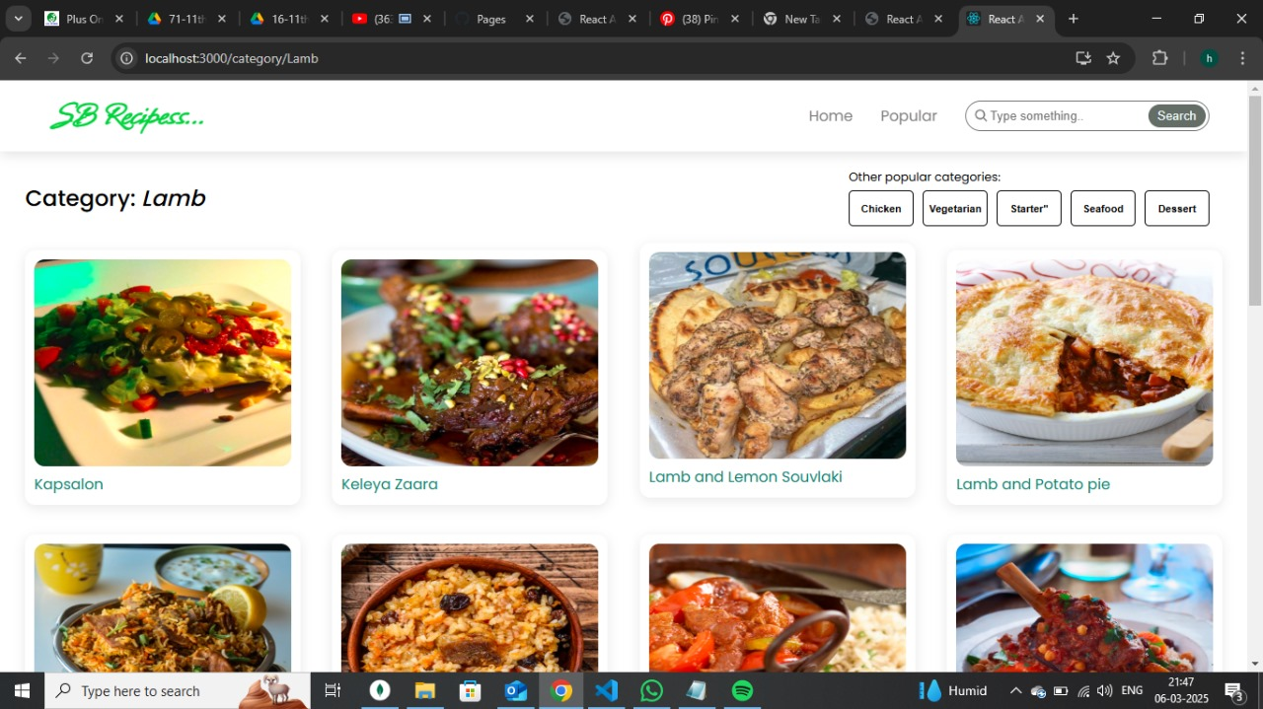

1. **CONCLUSION:**

The *CookBook* project successfully provides an interactive and user-friendly platform for exploring a wide range of recipes. By leveraging *React.js* for the frontend and integrating the *MealsDB API*, the application ensures real-time access to detailed recipe information, including ingredients, instructions, and images. The project demonstrates the seamless interaction between users and an external data source, enabling efficient search and retrieval of recipes.

Through careful *implementation of UI components, API integration, and responsive design, the application delivers a smooth user experience across different devices. The structured development approach, including **state management, navigation, and API handling*, ensures high performance and usability.

Overall, *CookBook* serves as a practical solution for food enthusiasts looking to discover and try new recipes. With future enhancements, such as *user authentication, personalized recommendations, and saved recipes*, the platform can be further improved to offer a more engaging and personalized experience.